Gippsland Lakes Coordinating Committee - Round 3 Community Grants Guidelines

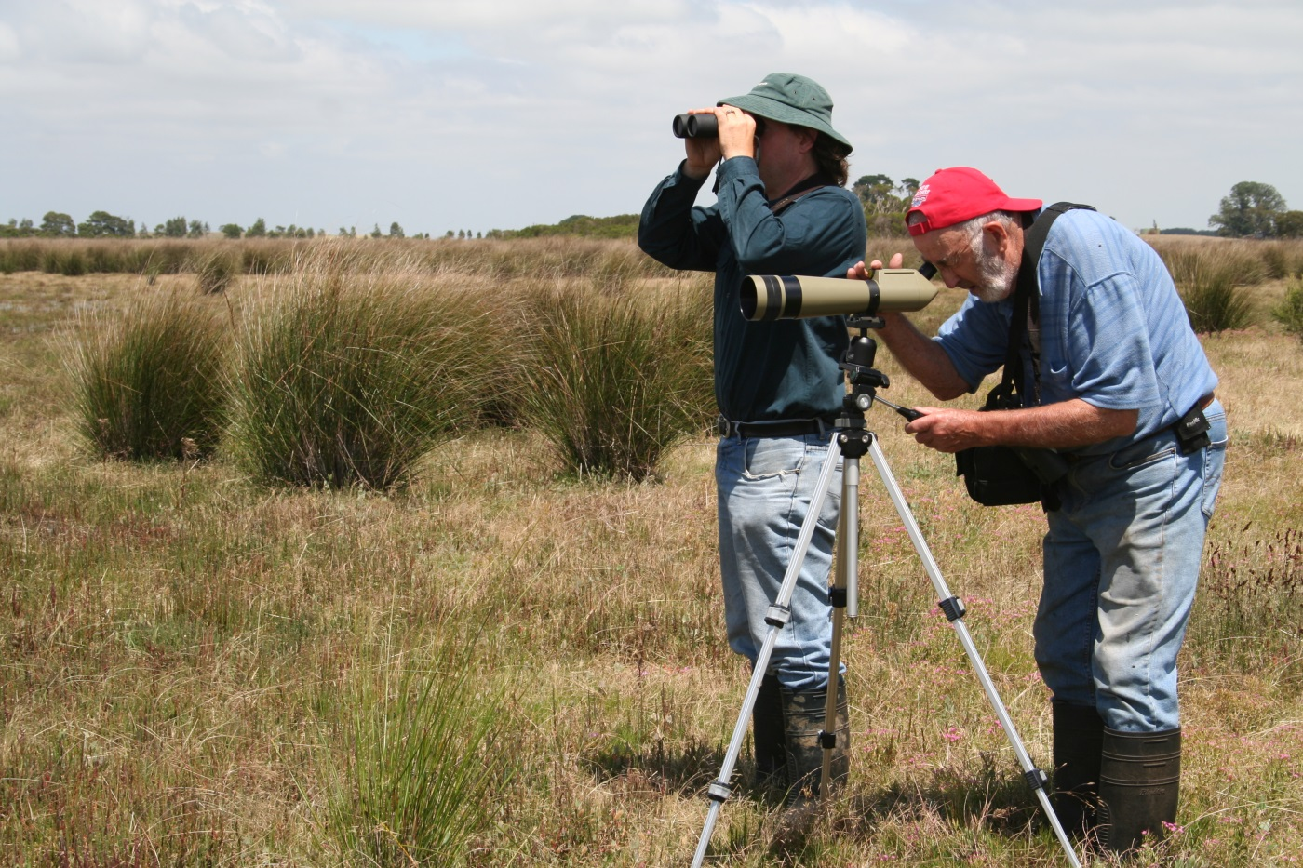

**1** **Background** 3

**1.1** **Introduction** 3

**1.2** **Objectives** 3

**2** **Eligibility** 4

**2.1** **General Eligibility** 4

**2.2** **Gippsland Lakes Priorities** 4

**2.3** **Victorian State Government Investment Principles** 9

**2.4** **General Conditions** 9

**2.5** **Occupational Health and Safety** 9

**2.6** **Reporting Requirements** 9

**3** **Assessment** 10

**3.1** **Eligibility (Eligible or not)** 10

**3.2** **Alignment to Priorities for the Gippsland Lakes (60%)** 10

**3.3** **Project Impact (20%)** 10

**3.4** **Project Design (20%)** 10

**3.5** **General Principles Used in Assessment** 11

**4** **Submission of Proposals** 12

**4.1** **Submission of Project Proposals** 12

**4.2** **Contact** 12

|  |
| --- |
| **Background** |

## **Introduction**

The Gippsland Lakes Coordinating Committee (GLCC) is tasked with making recommendations to the Minister for Water on the allocation of funding for the internationally significant Gippsland Lakes, with a specific focus on improving the environmental condition of the Gippsland Lakes.

The GLCC Community Grants Program is an important component of the $12.5 million Gippsland Lakes program being implemented by a range of organisations and community groups across the Gippsland Lakes catchment between now and June 2020.

A total of $285,000 will be made available for community projects to be delivered through Round 3 of the Gippsland Lakes Community Grants Program.

This document provides information on the GLCC Community Grants Program, including guidance on general eligibility, priorities based upon the Gippsland Lakes Priorities Plan[1], and the Victorian State Government investment principles.

Applicants are encouraged to read these guidelines before preparing project applications and wherever possible to align project proposals with state and regional priorities.

## **Objectives**

The objectives of the GLCC are to:

* Maintain or improve the health of the Gippsland Lakes;
* Foster cooperation and coordination between agencies and organisations with an interest in the health of the Gippsland Lakes;
* Integrate Traditional Owner knowledge and management;
* Promote awareness of and participation by communities in the management of the Gippsland Lakes; and
* Maximise outcomes through leveraging investments.

The projects proposed through this process should encompass these objectives. Please note this project proposal is for projects to be completed within 12 months of the provision of funds and with the specified reporting requirements fulfilled.

|  |
| --- |
| **Eligibility** |

## **General Eligibility**

For a project application to be eligible for consideration and assessment, the proponent Group or Network must:

* Be a ‘not-for-profit’ and community based;
* Have natural resource management (NRM) as a primary focus;
* Be incorporated or operate under the auspices of an incorporated organisation.
* Have current public liability ($10M) and personal accident insurance. (or operate under the auspices of an organisation that carries such insurance)
* Be able to provide a copy of the certificate of currency for public liability and personal accident insurance.
* Have submitted all due project reports for previous grants/funding to the EGCMA (where applicable).

## **Gippsland Lakes Priorities**

Proposed projects are required to meet two eligibility criteria related to the Gippsland Lakes Priorities Plan (the plan can be found on the Love Our Lakes website <http://www.loveourlakes.net.au>). If the project proposal cannot demonstrate how the criteria outlined below can be met, then the project is not eligible for funding through this process:

***Criteria 1 –*** *The implementation of the project must directly target a high priority value or threat as identified in the Gippsland Lakes Priorities Plan (see*

*Table* *1 and 2).*

The proposed project should be directly related to either a value or a threat (can be both) listed in Table 1 or Table 2.

Please note: the location of the project should be within the ‘mega-habitat’ type referenced in the table for that value or threat. Figure 1 shows the location of the defined ‘mega-habitats’ across the Gippsland Lakes.

***Criteria 2 –*** *The project will result in a direct contribution to a priority action/s as identified in the Gippsland Lakes Priorities Plan (see Table 3).*

The proposed project should provide a direct contribution to one (or more) of the priority actions listed in Table 3. The proposed project should provide a contribution to achieving the specific action/s in the location where it is to be delivered. These actions provide a direct link between on ground projects and the implementation of the Gippsland Lakes Ramsar Site Management Plan.

Table 1: Priority values in mega-habitats (see Figure 1) of the Gippsland Lakes Ramsar site [2]

| **Value** | **Mega-habitats** | | | | | |
| --- | --- | --- | --- | --- | --- | --- |
| **Deep lakes** | **Shallow lakes** | **Freshwater wetlands** | **Variably saline wetlands** | **Hypersaline wetlands** | **Estuarine reaches** |
| Marine sub-tidal beds (seagrass) |  |  |  |  |  |  |
| Coastal lagoons (open water phytoplankton) |  |  |  |  |  |  |
| Fringing freshwater wetlands |  |  |  |  |  |  |
| Fringing brackish wetlands |  |  |  |  |  |  |
| Saltmarsh |  |  |  |  |  |  |
| Abundance & diversity of waterbirds |  |  |  |  |  |  |
| Threatened species: Little tern and fairy tern |  |  |  |  |  |  |
| Abundance and diversity of native fish |  |  |  |  |  |  |
| Waterbird breeding |  |  |  |  |  |  |
| Burrunan dolphin (*Tursiops australis*) |  |  |  |  |  |  |
| Geomorphic features (silt jetties) |  |  |  |  |  |  |

Table 1 lists priority values of the Gippsland Lakes Ramsar Site.

The table also specifies which mega-habitat these values are a high priority. For your project to be eligible for Gippsland Lakes funding it must both address a value from this table (or a threat from table 2), and address that value (or threat) in the correct mega-habitat.

In other words your project must do the right thing *and* do it in the right place. The locations of mega-habitats within the Gippsland Lakes can be seen in the map at Figure 1.

Table 2: Priority threats for each mega-habitat (see Figure 1) of the Gippsland Lakes Ramsar site 2

| **Threat** | **Mega-habitats** | | | | | |
| --- | --- | --- | --- | --- | --- | --- |
| **Deep lakes** | **Shallow lakes** | **Freshwater wetlands** | **Variably saline wetlands** | **Hypersaline wetlands** | **Estuarine reaches** |
| Nutrient inflows from agricultural activities in the catchment |  |  |  |  |  |  |
| Development on the shores affecting visual amenity |  |  |  |  |  |  |
| Foxes and cats predating on waterbirds |  |  |  |  |  |  |
| Climate change (storms and sea level rise) affects silt jetties |  |  |  |  |  |  |
| Climate change (storms and sea level rise) impacts vegetation |  |  |  |  |  |  |
| Non-native invasive species (sea spurge) affects terns nesting |  |  |  |  |  |  |
| Non-native invasive plant species affects native flora and habitat |  |  |  |  |  |  |
| Native invasive species (e.g. Typha) affects flora diversity and habitat |  |  |  |  |  |  |
| Decreased freshwater inflows – impacts on breeding triggers for estuarine fish |  |  |  |  |  |  |
| Decreased freshwater inflows – altered water regimes impacts flora and fauna |  |  |  |  |  |  |
| Decreased freshwater inflows – increased salinity impacts flora and fauna |  |  |  |  |  |  |
| Disturbance of shorebirds and / or nesting birds by people and dogs |  |  |  |  |  |  |
| Vessels affecting the behaviour and condition of dolphins |  |  |  |  |  |  |
| Recreational vehicles causing physical damage to vegetation and habitat |  |  |  |  |  |  |
| Grazing and trampling on riparian/coastal habitats from deer pigs and rabbits |  |  |  |  |  |  |

**Figure 1: Locations of mega-habitats within the Gippsland Lakes**

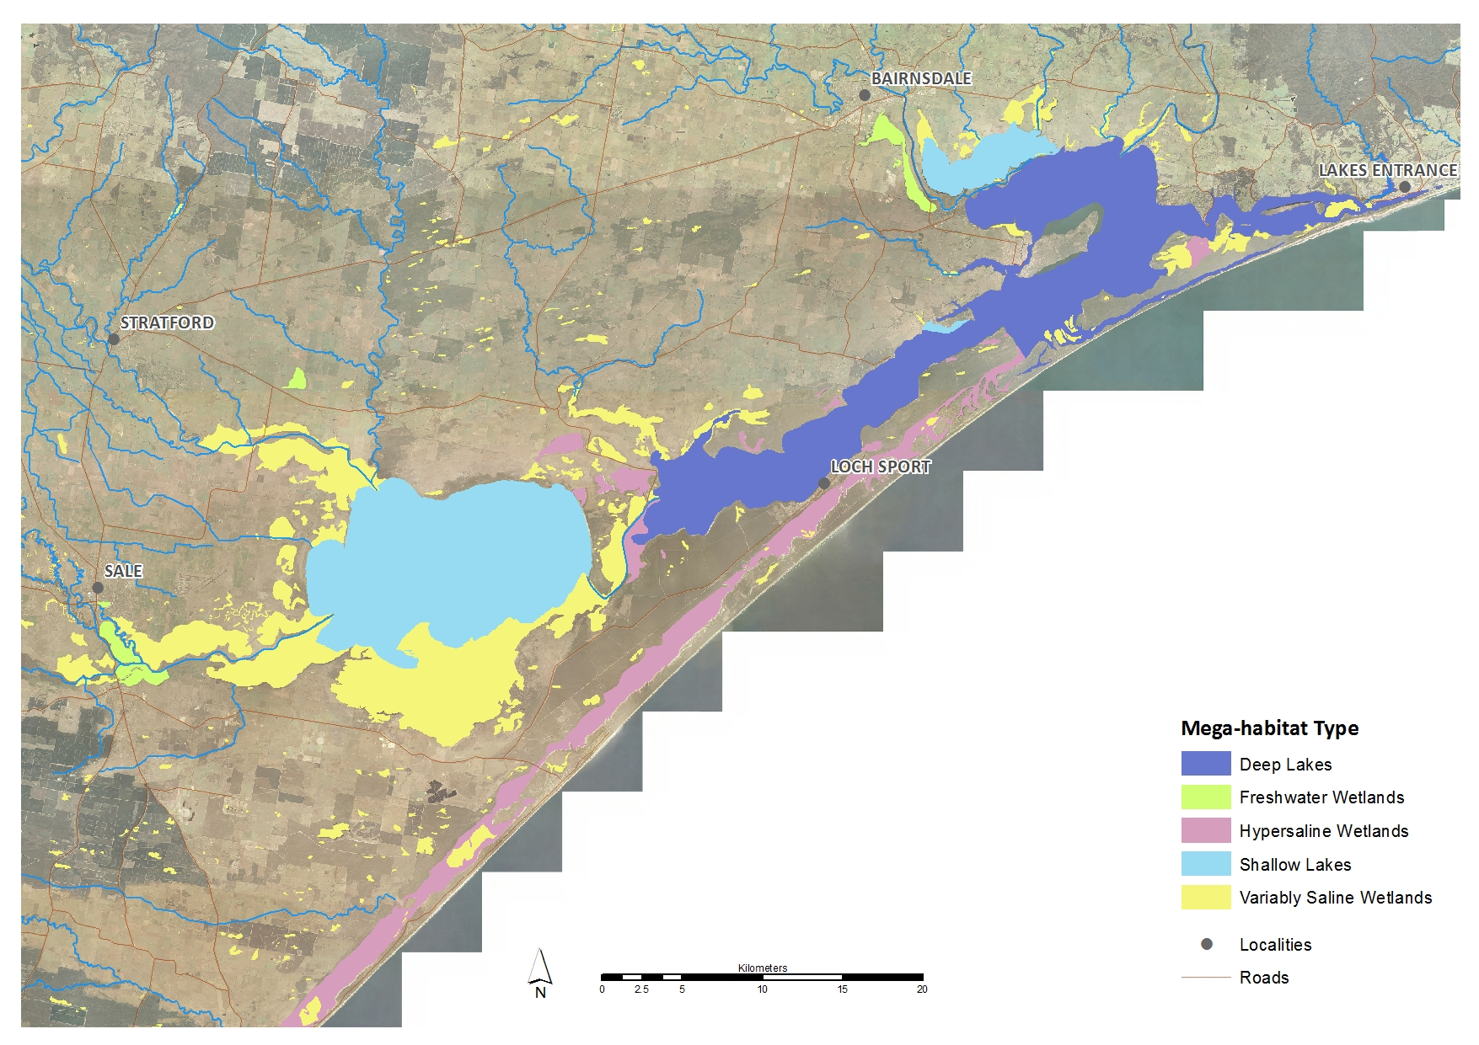

Table 3: Priority themes and actions

| **Priority actions - Maintaining and restoring habitats** |
| --- |
| * Investigate the risk and potential mitigation strategies for climate change impacts to ecological character of the Gippsland Lakes Ramsar site. |
| * Investigate options for improving the ecological condition of Lake Wellington |
| * Fence and revegetate lake and estuary shoreline; including the silt jetties |
| * Protect and restore habitat at little tern and fairy tern nesting and post-breeding sites. Manage sea spurge at little tern and fairy tern nesting sites |
| * Actively manage priority pest plants |
| * Control off-road vehicle use at priority locations within the Ramsar site |
| * Undertake research into the ecological consequences of algal blooms |
| **Priority actions - Protecting fauna** |
| * Assess the distribution of heavy metals and other contaminants (including mercury) in the Gippsland Lakes and the level of risk (i.e. bioavailability). |
| * Investigate priority species and locations for waterbird breeding and migratory wader refuges within the Ramsar site. |
| * Control introduced predators in priority bird areas |
| * Investigate the risk posed by human disturbance to migratory waders develop and implement feasible actions to address the risks |
| * Develop and implement a public awareness campaign to reduce harassment and boating injuries to Burrunan dolphins |
| * Consolidate, refine and promote fisheries management arrangements to ensure a sustainable fishery |
| * Implement an introduced marine pest strategy for the Gippsland Lakes |
| **Priority actions - Managing nutrients and sediments** |
| * Reduce nutrient and sediment loads to the Gippsland Lakes through riparian, in-stream and catchment works to improve water quality of river flows to the Gippsland Lakes. |
| * Investigate the impacts of altered freshwater inflows on nutrient cycling and productivity in the Deep Lakes, including thresholds for change |
| * Investigate the impact of high nutrient and sediment loads to fresh and variably saline wetlands following bushfires |
| **Priority actions - Managing water regimes** |
| * Undertake regular planning, delivery, monitoring and evaluation of the use of environmental water entitlements in the lower Latrobe wetlands (Sale Common, Heart Morass, Dowd Morass) and the Latrobe River estuary. |
| * Investigate and implement actions that facilitate effective management of the water and salt regimes of priority fringing wetlands, including Sale Common, Heart Morass, Dowd Morass, Lake Reeve and Macleod Morass. |
| * Maintain and where necessary improve hydrological connectivity and freshwater inflows to the Gippsland Lakes for fish migration and breeding. |

## **Victorian State Government Investment Principles**

For a project application to be eligible for consideration and assessment, the project proposal must also meet Victorian State Government investment principles listed below.

* Community projects address local and regional environmental priorities through the delivery of on-ground works.
* Clear public benefit is demonstrable in the use of all GLCC funding.
* Grants to groups can include no more than 15% project management for each project. Project management costs are to be included within the groups project budget and must be clearly attributable to the delivery of project outputs.
* Funding cannot be used to support professional or organisational project management services, however funds may be used for contractors or consultants essential to the delivery of the project for technical or capability reasons.
* When promoting GLCC community grants funding it is a requirement that the Victorian Government be acknowledged as the source of these funds and be badged as being funded by the Victorian State Government according to branding guidelines and include the appropriate “Love Our Lakes” logo when promoting the projects (a style guide will be provided to successful applicants).

## **General Conditions**

* Weed control on private land will not be funded unless the activity is preparatory to revegetation works or associated with native vegetation management.
* Capital items exceeding a value of $1,000 will not be funded unless communal benefit can be demonstrated.
* Where project grants exceed $10,000 projects must demonstrate at least 50% on-ground works.
* Capacity building or community engagement-type projects must be coupled with relevant on-ground works.
* Project grants cannot be used to fund on-going maintenance activities.
* Recipients are responsible for seeking and obtaining all relevant permits to undertake the proposed works. This includes permission from land manager (if required), planning permits, works on waterways permits, cultural heritage etc.

## **Occupational Health and Safety**

A safe system of work is required to be in place for your project to protect the health and safety of your group, volunteers and anyone else on your project site. You can find resources on OHS tailored to volunteers and community groups on the Worksafe Victoria website: <http://www.worksafe.vic.gov.au/safety-and-prevention/your-industry/local-government/your-legal-duties/volunteers>

## **Reporting Requirements**

Successful Groups / Networks will be required to sign and enter into a funding agreement with the East Gippsland Catchment Management Authority (the Authority). Reporting requirements will be defined in the agreement and are aligned with the Authority’s reporting obligations to the Investor (Victorian State Government). Templates for progress and final reports will be provided to the funding recipient by the Authority to guide supply of the required information.

|  |
| --- |
| **Assessment** |

The following factors will be considered in the assessment of individual projects. The weighting of each project component is shown in brackets.

## **Eligibility (Eligible or not)**

Only proponents and projects that meet the Eligibility Criteria listed below, and in Section 2, will be eligible for assessment. Proponents/projects not meeting these criteria will not be considered.

***Criteria 1 –*** *The implementation of the project must directly target a high priority value or threat identified in the Gippsland Lakes Priorities Plan (see*

*Table* *1 and 2).*

***Criteria 2 –*** *The project will result in a direct contribution to a priority action/s as identified in the Gippsland Lakes Priorities Plan (see Table 3).*

## **Alignment to Priorities for the Gippsland Lakes (60%)**

The extent to which the project proposal aligns with the GLCC Objectives;

* Maintain or improve the health of the Gippsland Lakes;
* Foster cooperation and coordination between agencies and organisations with an interest in the health of the Gippsland Lakes;
* Integrate Traditional Owner knowledge and management;
* Promote awareness of and participation by communities in the management of the Gippsland Lakes; and
* Maximise outcomes through leveraging investments

## **Project Impact (20%)**

How well does the project address the following factors?

* Longevity of impact, e.g. investment security through Landholder agreements.
* Use of demonstrated best practice methods for proposed on ground works.
* Community/Stakeholder support.
* Public/community benefit.

## **Project Design (20%)**

How well does the proposal demonstrate a well-considered and designed project? For example,

* How well will the proposed approach address the issue?
* Will it address the cause of the problem, rather than the symptom?
* Consideration of risks to investment, e.g. seasonality of works.
* How well is the project resourced to complete the project?
* Is the group appropriately connected to access expertise as required?
* How will progress be tracked?
* Are costs clearly defined and realistically budgeted?
* Are there links to groups or regional plans, if appropriate?

Project design evaluation will also consider the applicants history of previous project implementation and completion (if applicable), e.g. reporting, timely applications for variation and project completion, project quality.

## **General Principles Used in Assessment**

In addition to the assessment points noted above, the following attributes of the proposed project will be considered and assessed in determining successful project proposals:

* Value for money – defined generally as a large amount of output (considering quality, quantity and type of works) when compared with similar project proposals and industry standards.
* Consultation with, and involvement of, the Traditional Owners of the Gippsland Lakes, the Gunaikurnai people.

|  |
| --- |
| **Submission of Proposals** |

## **Submission of Project Proposals**

Please complete the accompanying project application form and submit by the due date outlined below. If additional space is required as part of your application please modify the electronic copy of the application form, or attach additional sheets **clearly marked** with the section of the application form the information relates to.

Applications are to be submitted to:

Carolyn Cameron

**No later than 9am Wednesday 16th May 2018**

By mail: East Gippsland Catchment Management Authority

PO Box 1012

Bairnsdale

VIC 3875; or

By email: [grants@egcma.com.au](mailto:grants@egcma.com.au)

## **Contact**

Project proponents are encouraged to discuss their proposed project while preparing their proposal. Staff from the East Gippsland Catchment Management Authority are available discuss project ideas and provide information and guidance for groups preparing project proposal for submission.

**Further information**

If you have any questions or queries please contact:

**Carolyn Cameron**

Community Projects Officer

Phone: (03) 5150 3582

Email: ccameron@egcma.com.au

**Sean Phillipson**

NRM Projects Manager

Phone: (03) 5150 3579

Email: sphillipson@egcma.com.au

1. EGCMA, 2016. Gippsland Lakes Priorities Plan. East Gippsland Catchment Management Authority.
2. EGCMA 2015. Gippsland Lakes Ramsar Site Management Plan. East Gippsland Catchment Management Authority, Bairnsdale, Victoria.